**Assignment : Auto-Tagging EC2 Instances on Launch Using AWS Lambda and Boto3**

IAM Role for Lambda

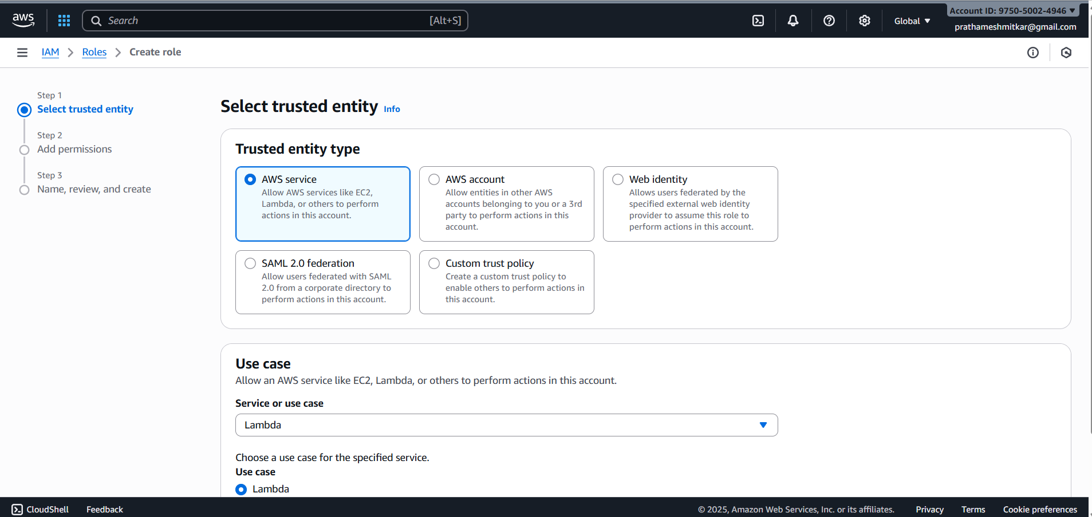

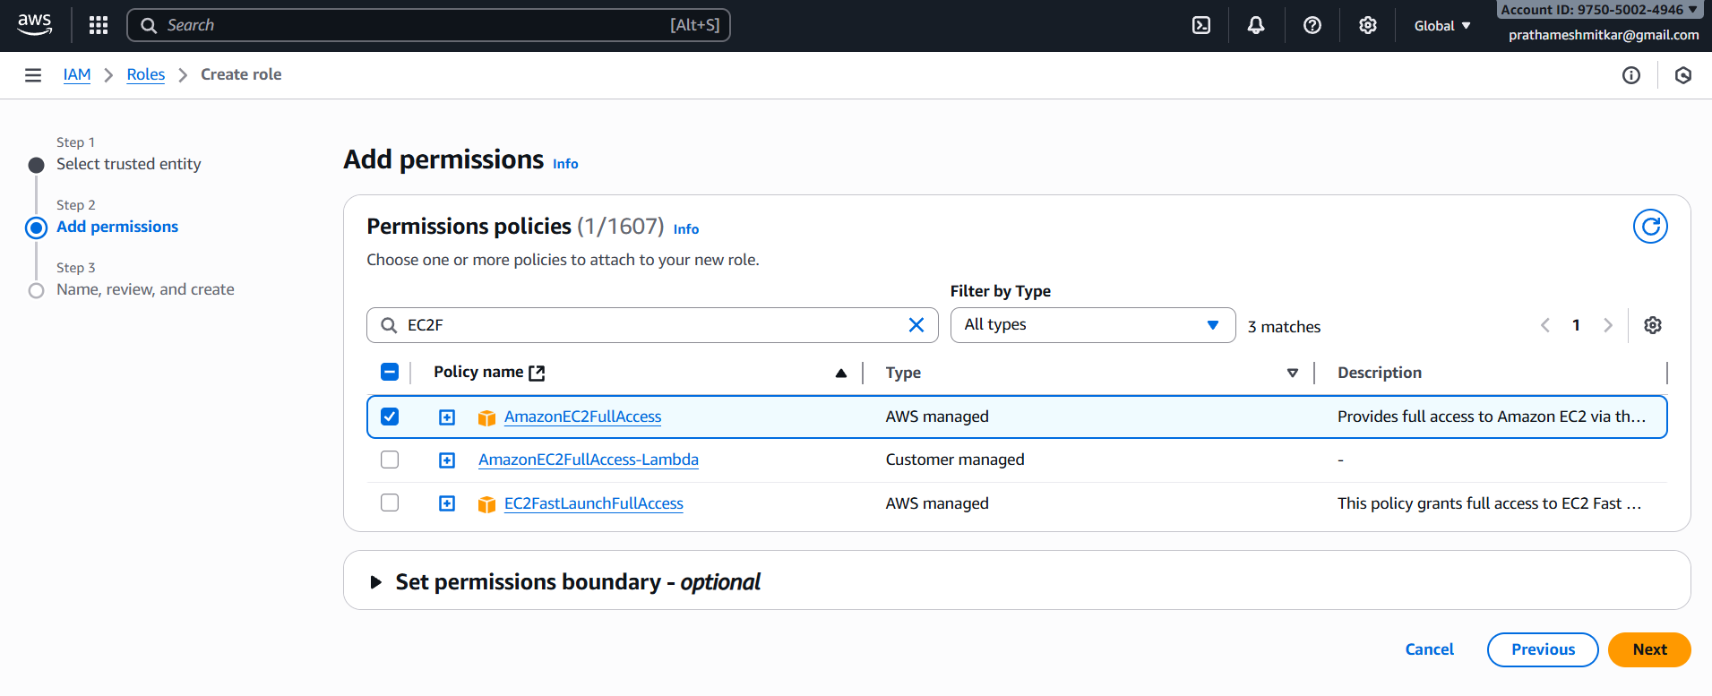

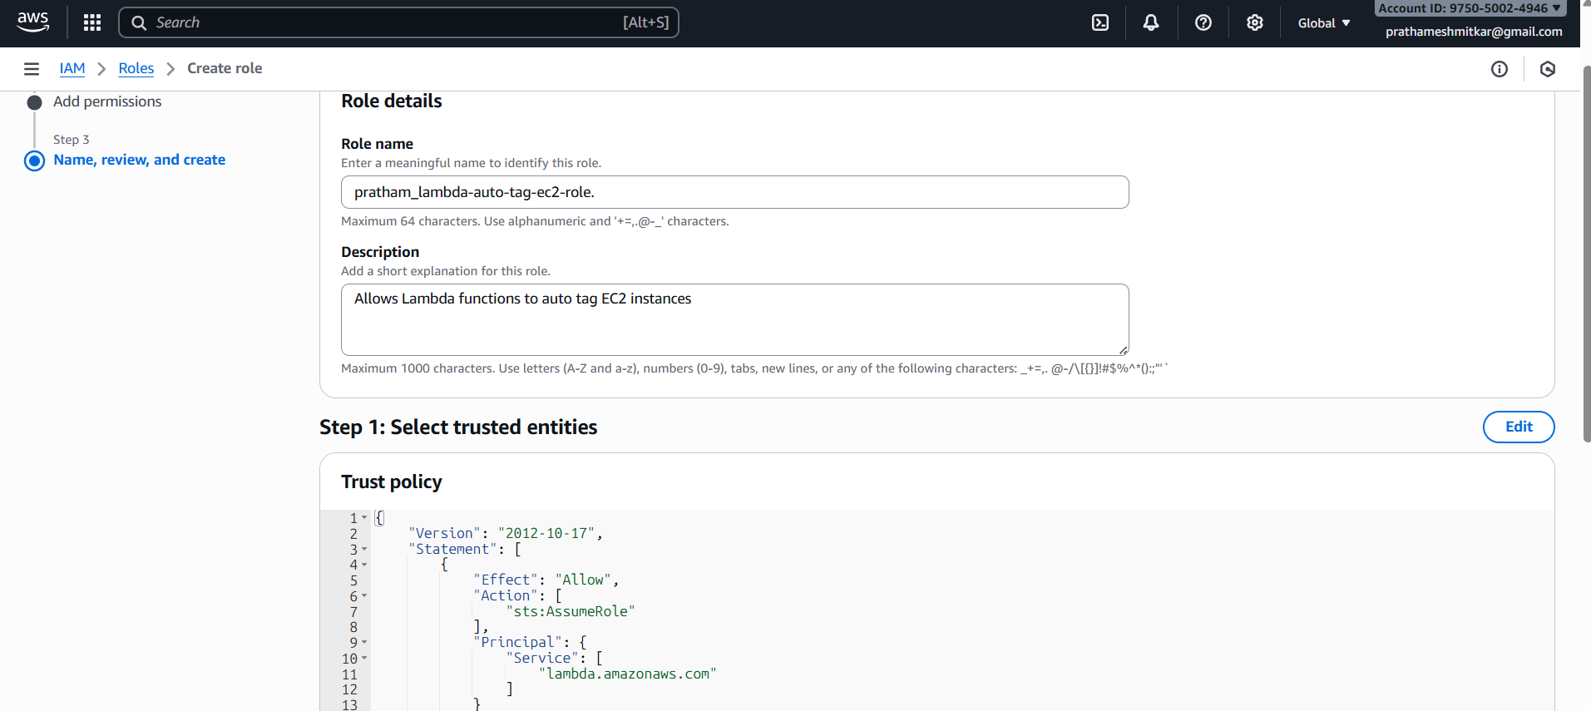

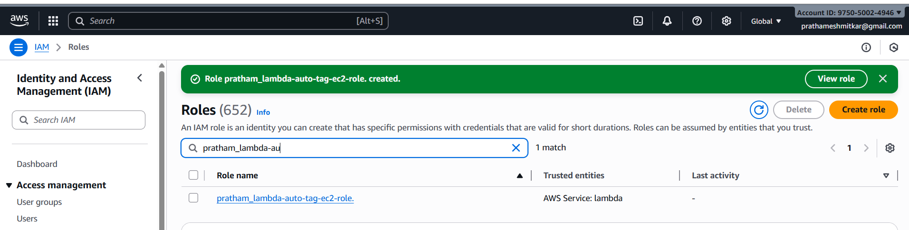

**Lambda function — create & configure**

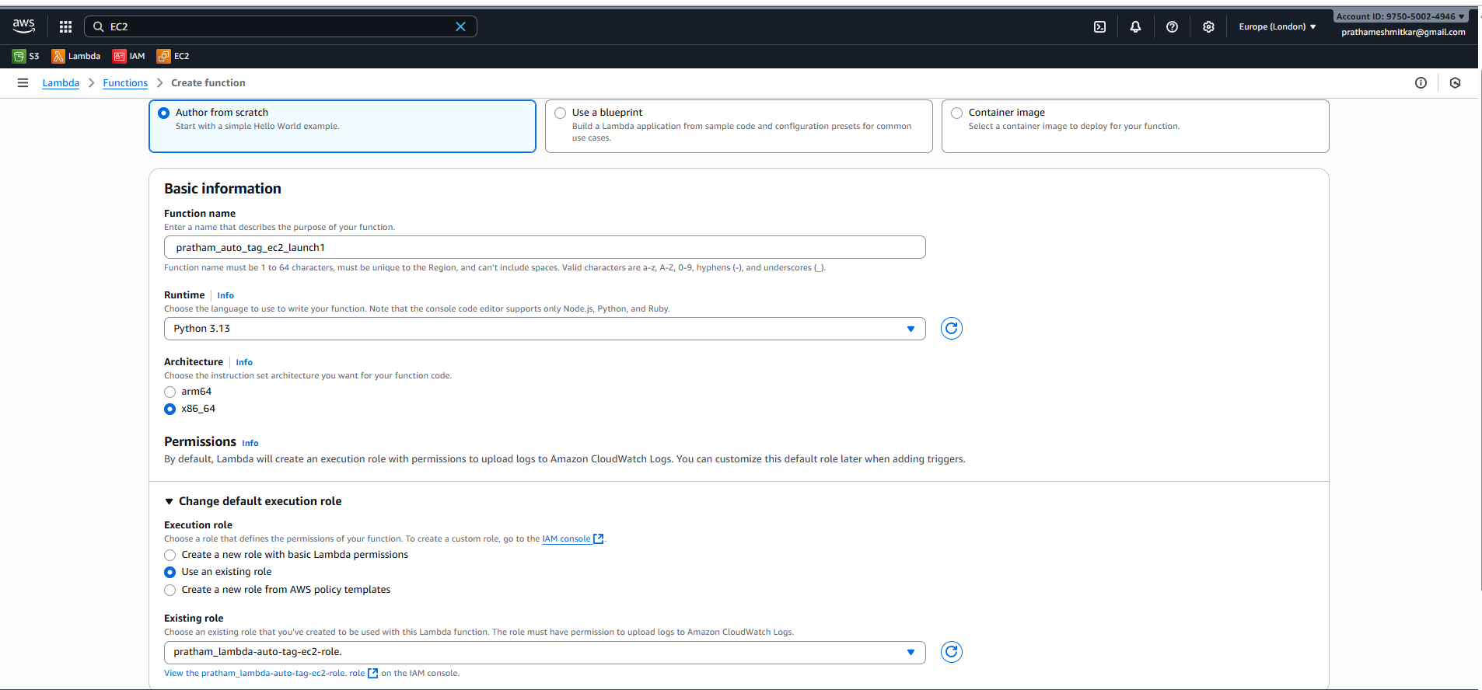

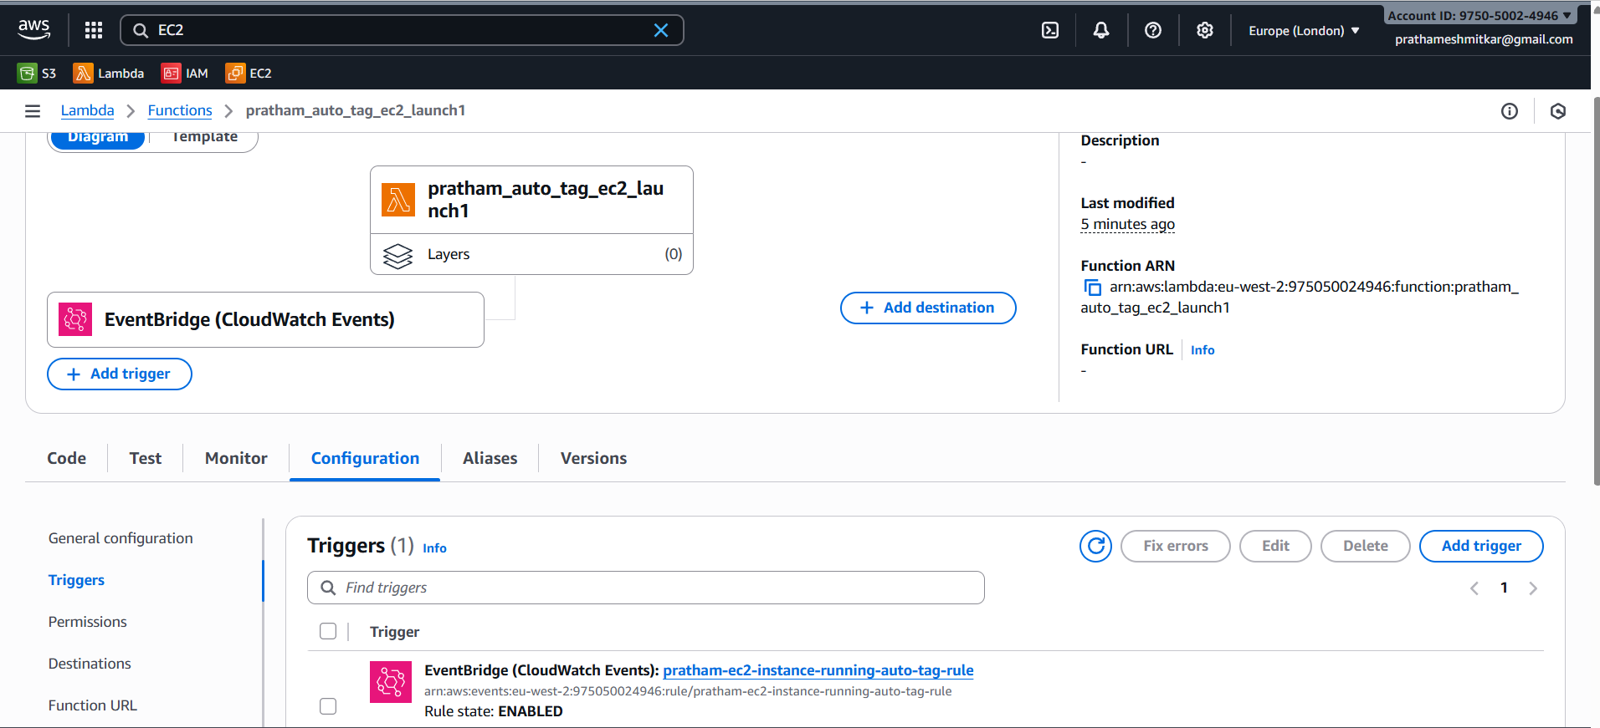

Add environment variables to lambda function so that you can make changes without editing the code

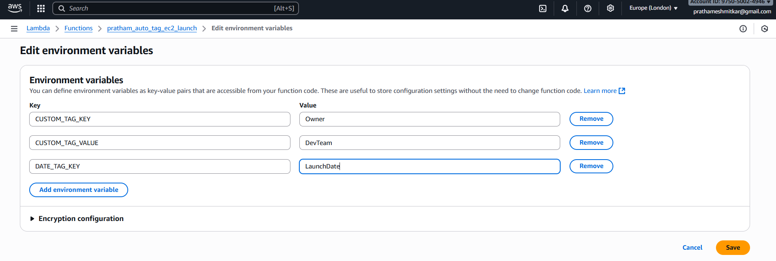

Update python code in the lambda.

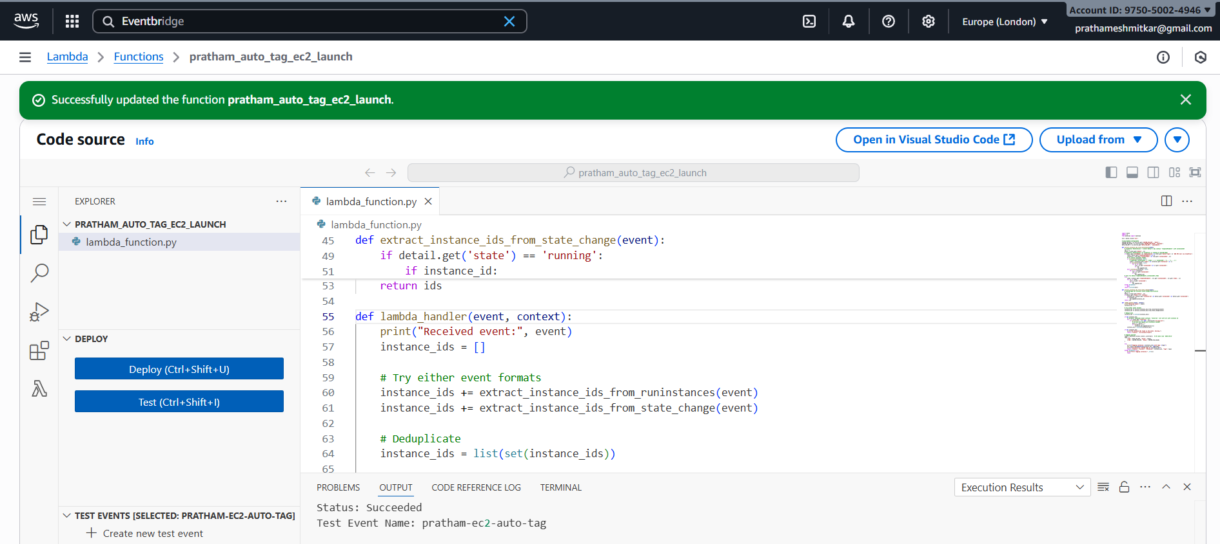

**Setting up a CloudWatch Event Rule to trigger the EC2 instance launch even**

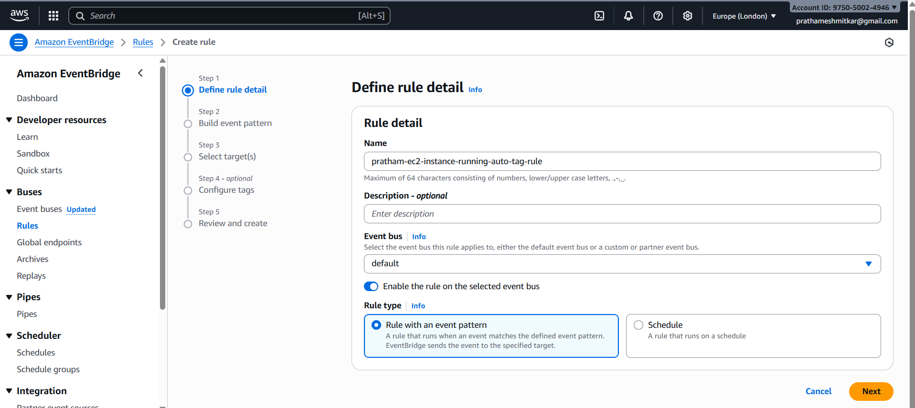

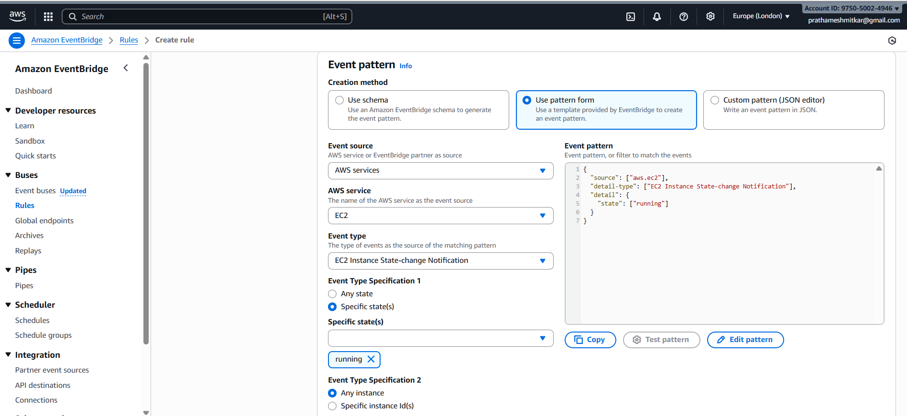

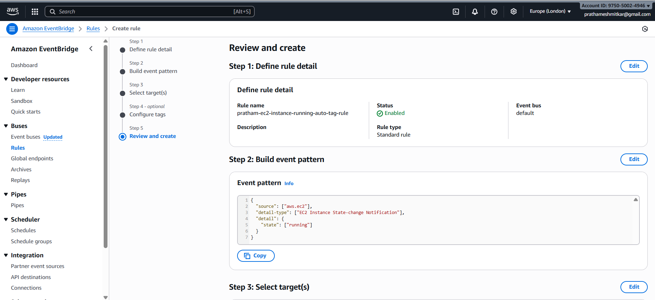

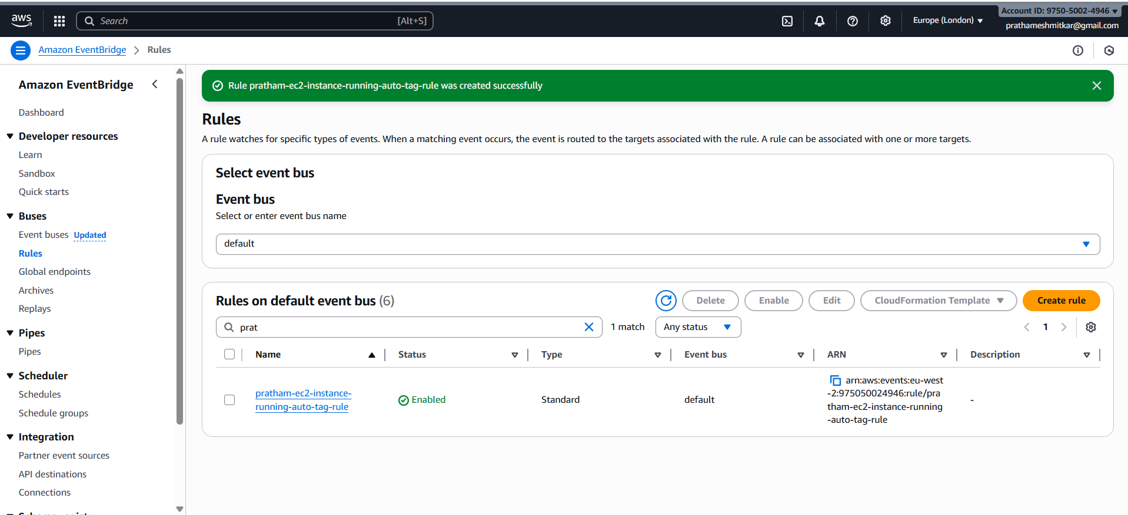

**Once Event rule is created add the trigger in Lamda function.**

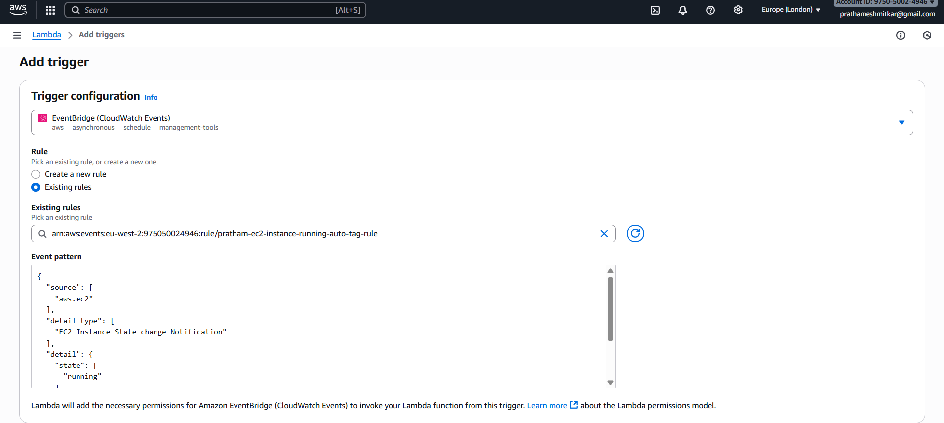

 **Assignment 5: Auto-Tagging EC2 Instances on Launch Using AWS Lambda and Boto3**

IAM Role for Lambda









**Lambda function — create & configure**

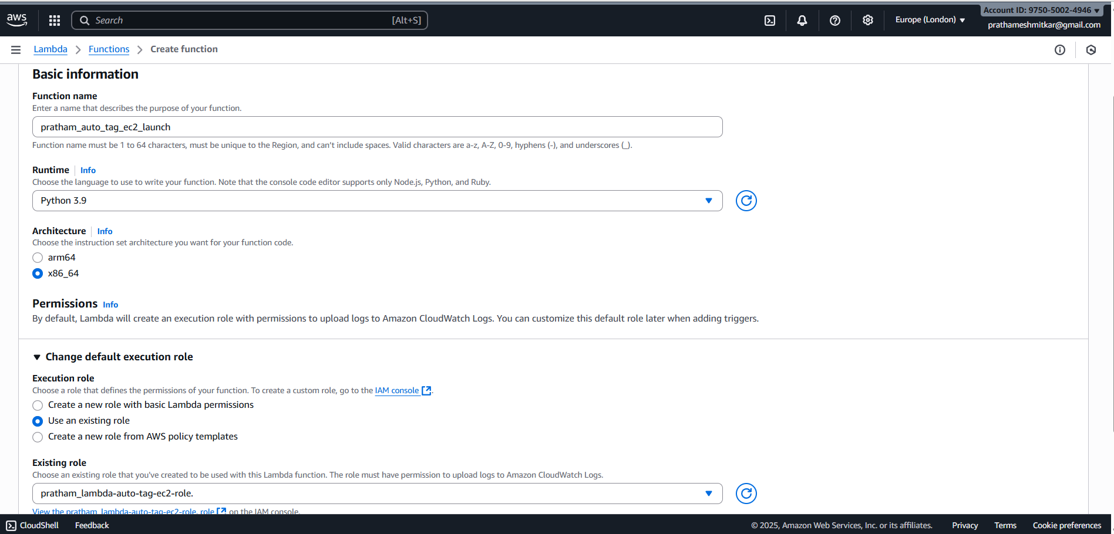

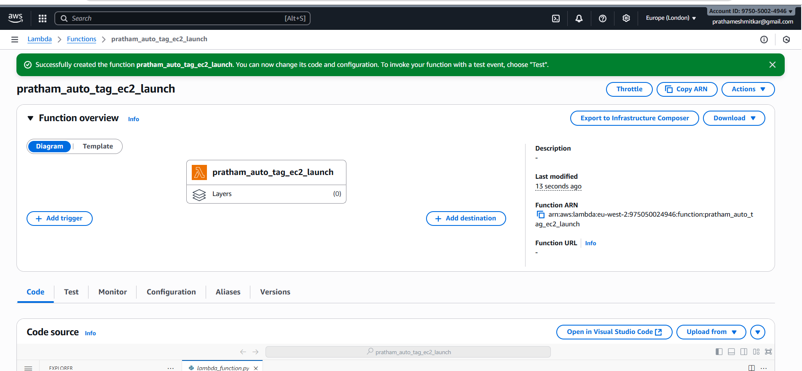

Add environment variables to lambda function so that you can make changes without editing the code



Update python code in the lambda.



**Setting up a CloudWatch Event Rule to trigger the EC2 instance launch even**





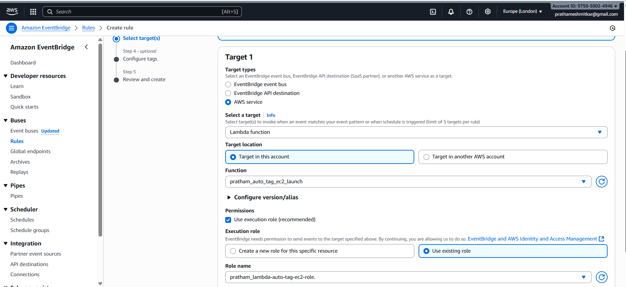





**Once Event rule is created add the trigger in Lamda function.**



**Launching an EC2 to test.**

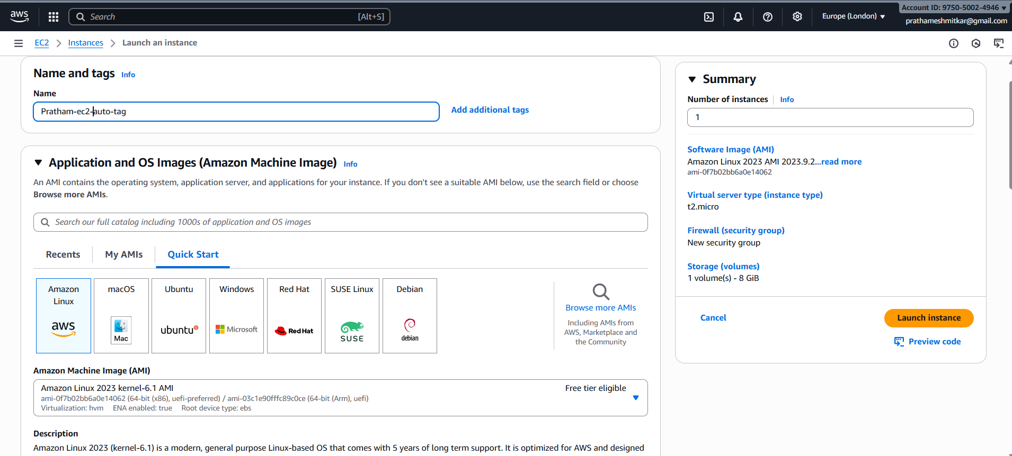



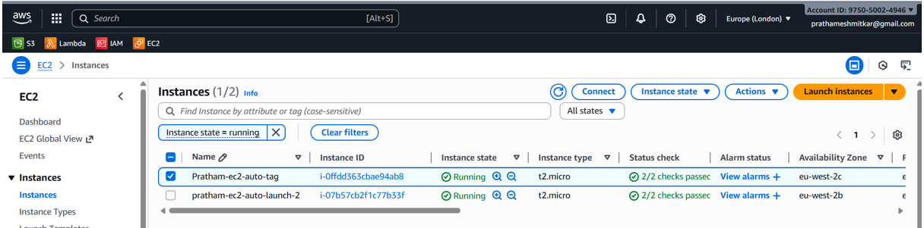

**Once the EC2 instances are in running state, the event triggers the lambda.**

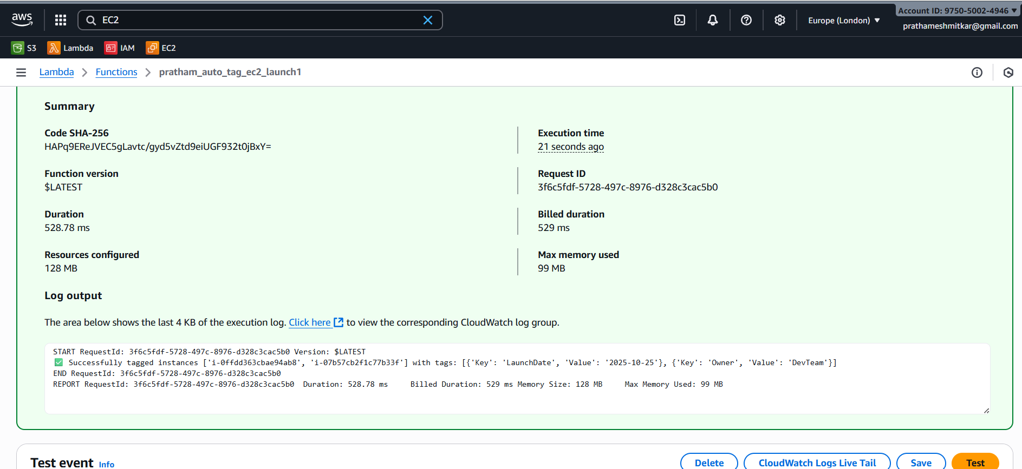

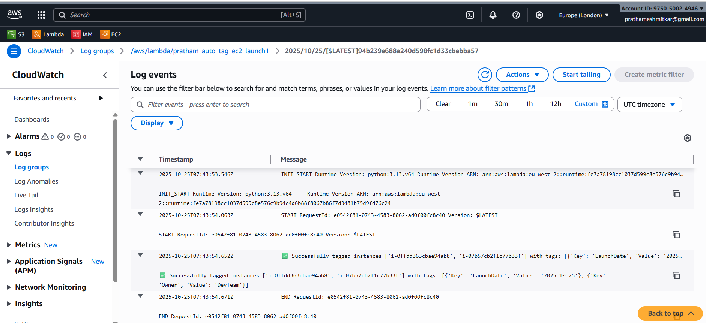

**Once the lambda is triggered, the EC2 instances are tagged.**

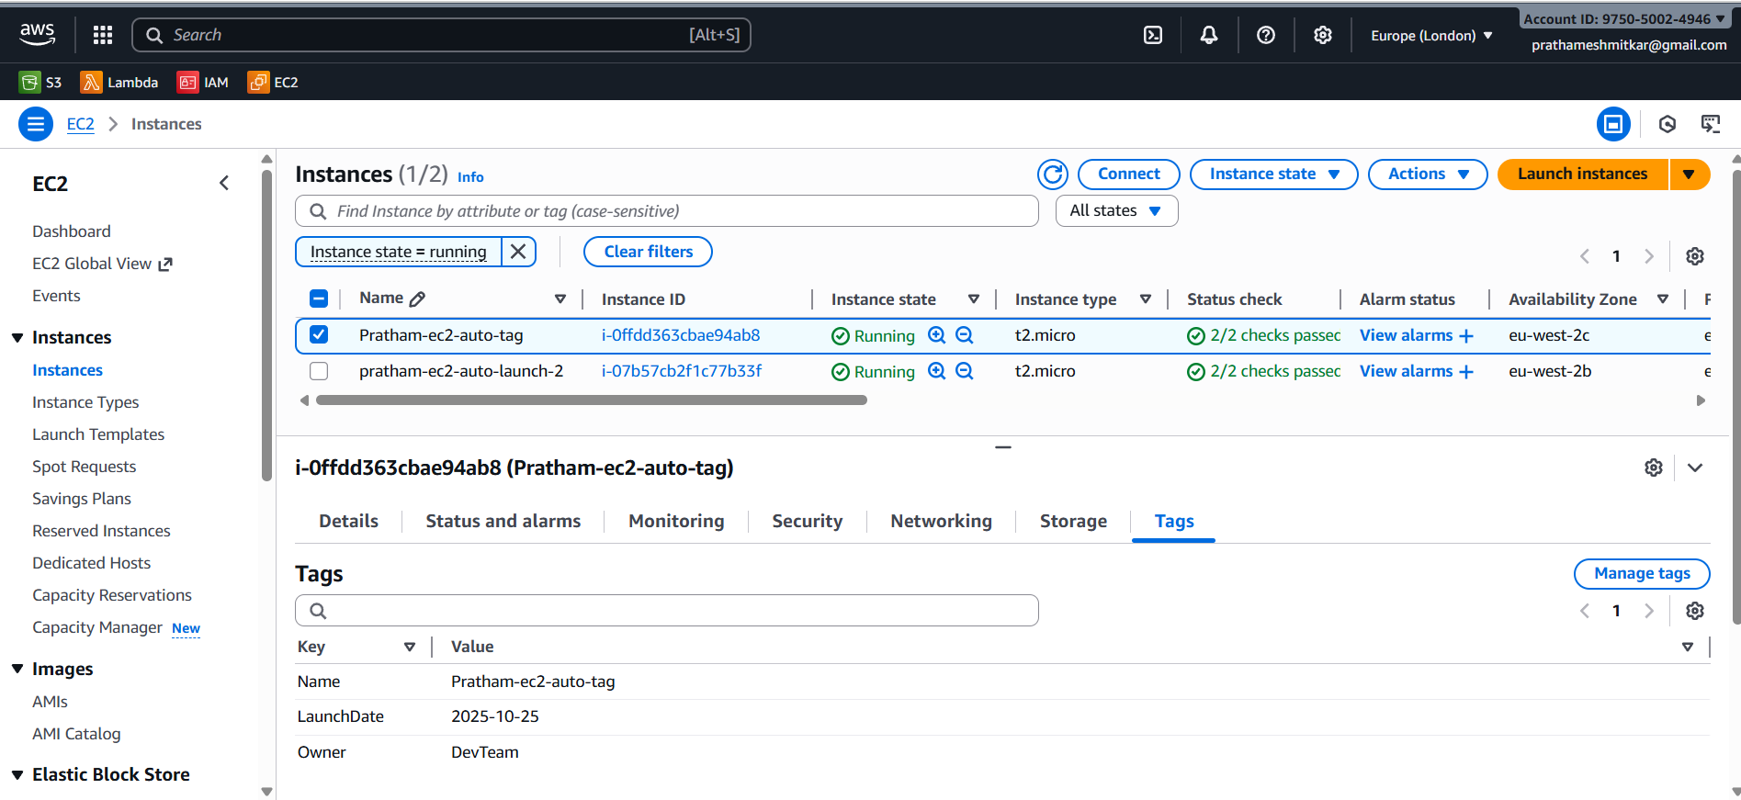

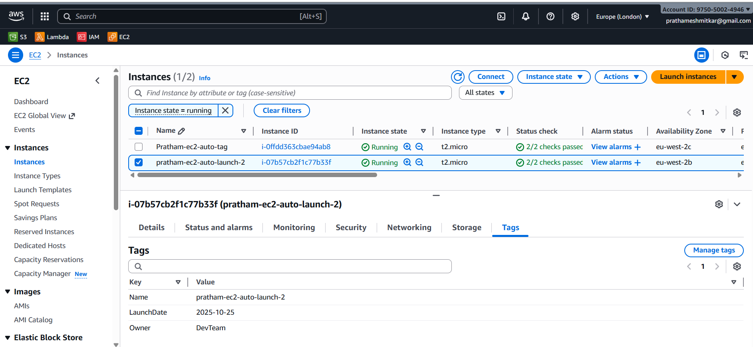

**Python Script and the Cloudwatch logs**

